Things I learned from lngo:

* No need for maui, just torque
* All centOS
* There is no parallel file system (“good news”) - NFS
* Will need 6th node

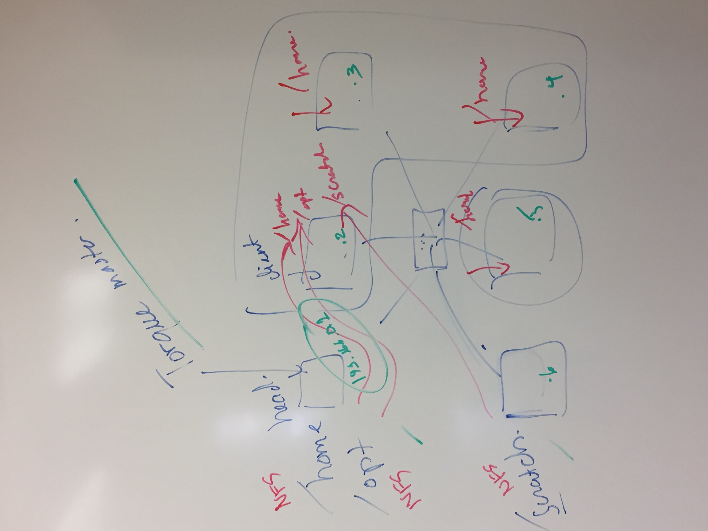

1. Set up static ip address on each node in profile only to be able to use scripts
2. Install torque master on head node and torque client on all others
   1. Should only be a difference in configuration, installation pretty much the same
3. Set up /home and /opt on head node
4. Set up /scratch on 6th node
5. When installing gcc and openMPI on opt of head node, they should be automatically put in other nodes if set up correctly
6. Need to set up environmental modules

Next Steps and Suggested Distribution of work:

First set up static IPs

Person 1: Install torque master on head node and torque client on all others

* Should only be a difference in configuration, installation pretty much the same

Person 2: Figure out how to mount /home and /opt on head node and /scratch on 6th node

Person 3: Set up gcc and open mpi on /opt and learn how to set up environmental modules

Person 4: “I don’t know what the 4th person will do” – Probably have them help out other members or assist in whatever is hardest.

